# Representations of Choice: Temporal Discounting

# INTRODUCTION

Temporal discounting is the phenomenon by which the subjective value associated with a reward diminishes because of a delay in its receipt. As the delay to a reward increases, the reward itself is judged to be equivalent to smaller rewards. We are constantly confronted with rewards that might be provided to us at a later date, for instance, studying towards our degrees, receiving refunds, or even credit card rewards. This makes temporal discounting an important behavior to understand and model from a neuroeconomics perspective. It provides an insight into delayed gratification, how the effect of time and value is evaluated cognitively, and has an impact on everyday decision-making processes.

A simple example, as described in (Kable & Glimcher, 2007), showcases temporal discounting succinctly. It states that an individual who has a check for $20, payable in a week, may trade it in for $18 immediately, and if the same $20 check is payable in a month, they may trade it in for $15 immediately. Thus, the subjective value associated with the $20 check diminishes as the time before the check can be cashed in increases.

The decline of subjective value associated with an object with an increase in delay of its receipt varies across individuals. The individual-specific function that describes how their subjective value decreases with an increase in delay is known as a discounting function. The neural basis of temporal discounting, and hence the possible discounting functions, have two major schools of thought (Peters & Büchel, 2010):

1. Immediate rewards have a special weight associated with them by the limbic system (β), and a more cognitive, well-thought reward associated with delayed rewards, conferred by the pre-frontal cortex-based system (δ). This forms the β-δ system, and its discount function is represented as a combination of exponential functions:

$\text{Subjective Value}= \frac{e^{-βD}+ e^{-δD}}{2}$ Equation (1)

where D is the delay associated with the expected reward.

1. There is a single system that evaluates delays and the associated rewards, and consists of the medial pre-frontal cortex (mPFC), posterior cingulate cortex (PCC) and the ventral striatum (VS). This is usually modelled by a hyperbolic function, and a subject specific parameter k:

$\text{Subjective Value = }\frac{1}{1+kD}$ Equation (2)

where D is the delay associated with the expected reward.

The hyperbolic function describes the discount function well, and is supported by existing literature. (Kabel & Glimcher, 2007; Kabel & Glimcher, 2010; Peters & Büchel, 2010). The k-value used to generate the fit function is representative of the patience of the participant, or their sensitivity to delay. Participants with less patience are more sensitive to delays, have higher discounting, and a large k-value, while patient participants are less sensitive to delays, show less discounting, and a small k-value. The graphs expected to be generated by patients with higher or lower k-values are shown in Figure 1. (Critchfield and Kollins, 2001).

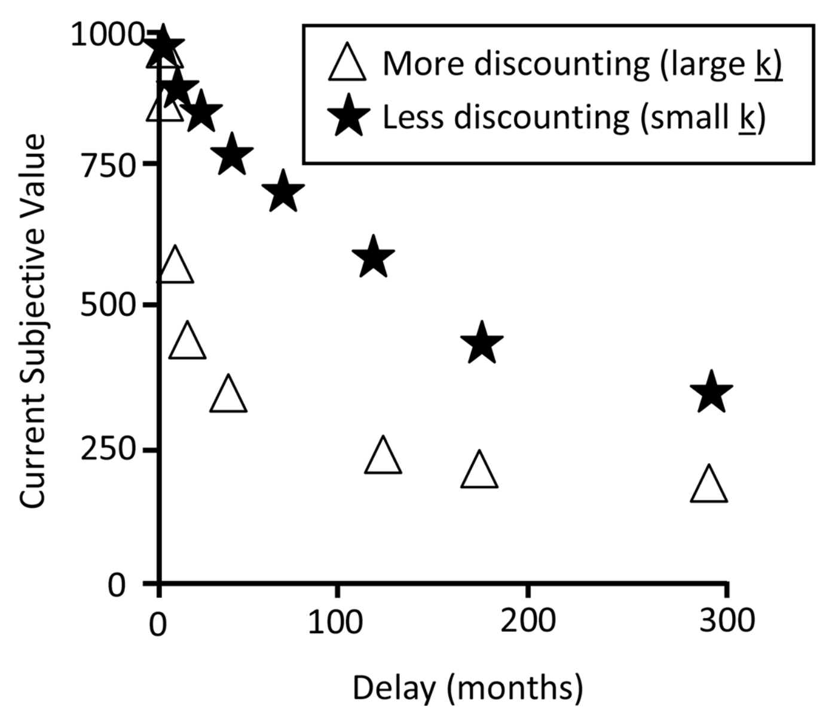

Figure 1: Hypothetical hyperbolic delay discounting curves (Critchfield & Kollins, 2001)

To study temporal discounting, we collected information about the preferences of our classmates, presenting them with choices between smaller immediate rewards and larger delayed rewards. We collected basic demographic information, including their age and degree of study, as well as information regarding their state of mind, characterized by their self-reported happiness and stress scores, as well as how much sleep they had the previous night. To estimate socio-economic influences, we gathered data about how their monthly expenses are distributed between essentials, investments and leisure activities. We hypothesized that the patience shown by an individual at any point of time is impacted by their individual tendencies and their current state of mind. Their state of mind and willingness to wait for a reward would also be affected by their socio-economic status, and their currently available economic resources. While there may be some impact of demographic information, since our subjects are close in age [21-26, mean 21.9], this may not be a differentiating factor.

# MATERIAL & METHODS

In each trial, participants were presented with a choice between receiving $20 immediately, or a larger amount after a delay. The larger amounts were picked from the set of {$25, $30, $50, $65, $80, $130}, and the delay was selected from the set of {1 week, 2 weeks, 1 month, 3 months, 6 months, 1 year}. Each of these randomly selected 36 combinations was presented twice, for a total of 72 trials. The trial consisted of a 1 second fixation cross, after which the choice was presented, in which participants were allotted a maximum of 10 seconds to choose between the immediate $20 amount (selected by pressing the key ‘1’), or the later, larger amount (selected by pressing key ‘2’). There was an unjittered, 0.5 second inter-trial delay, represented by a blank screen. A sample trial is shown in Figure 2.

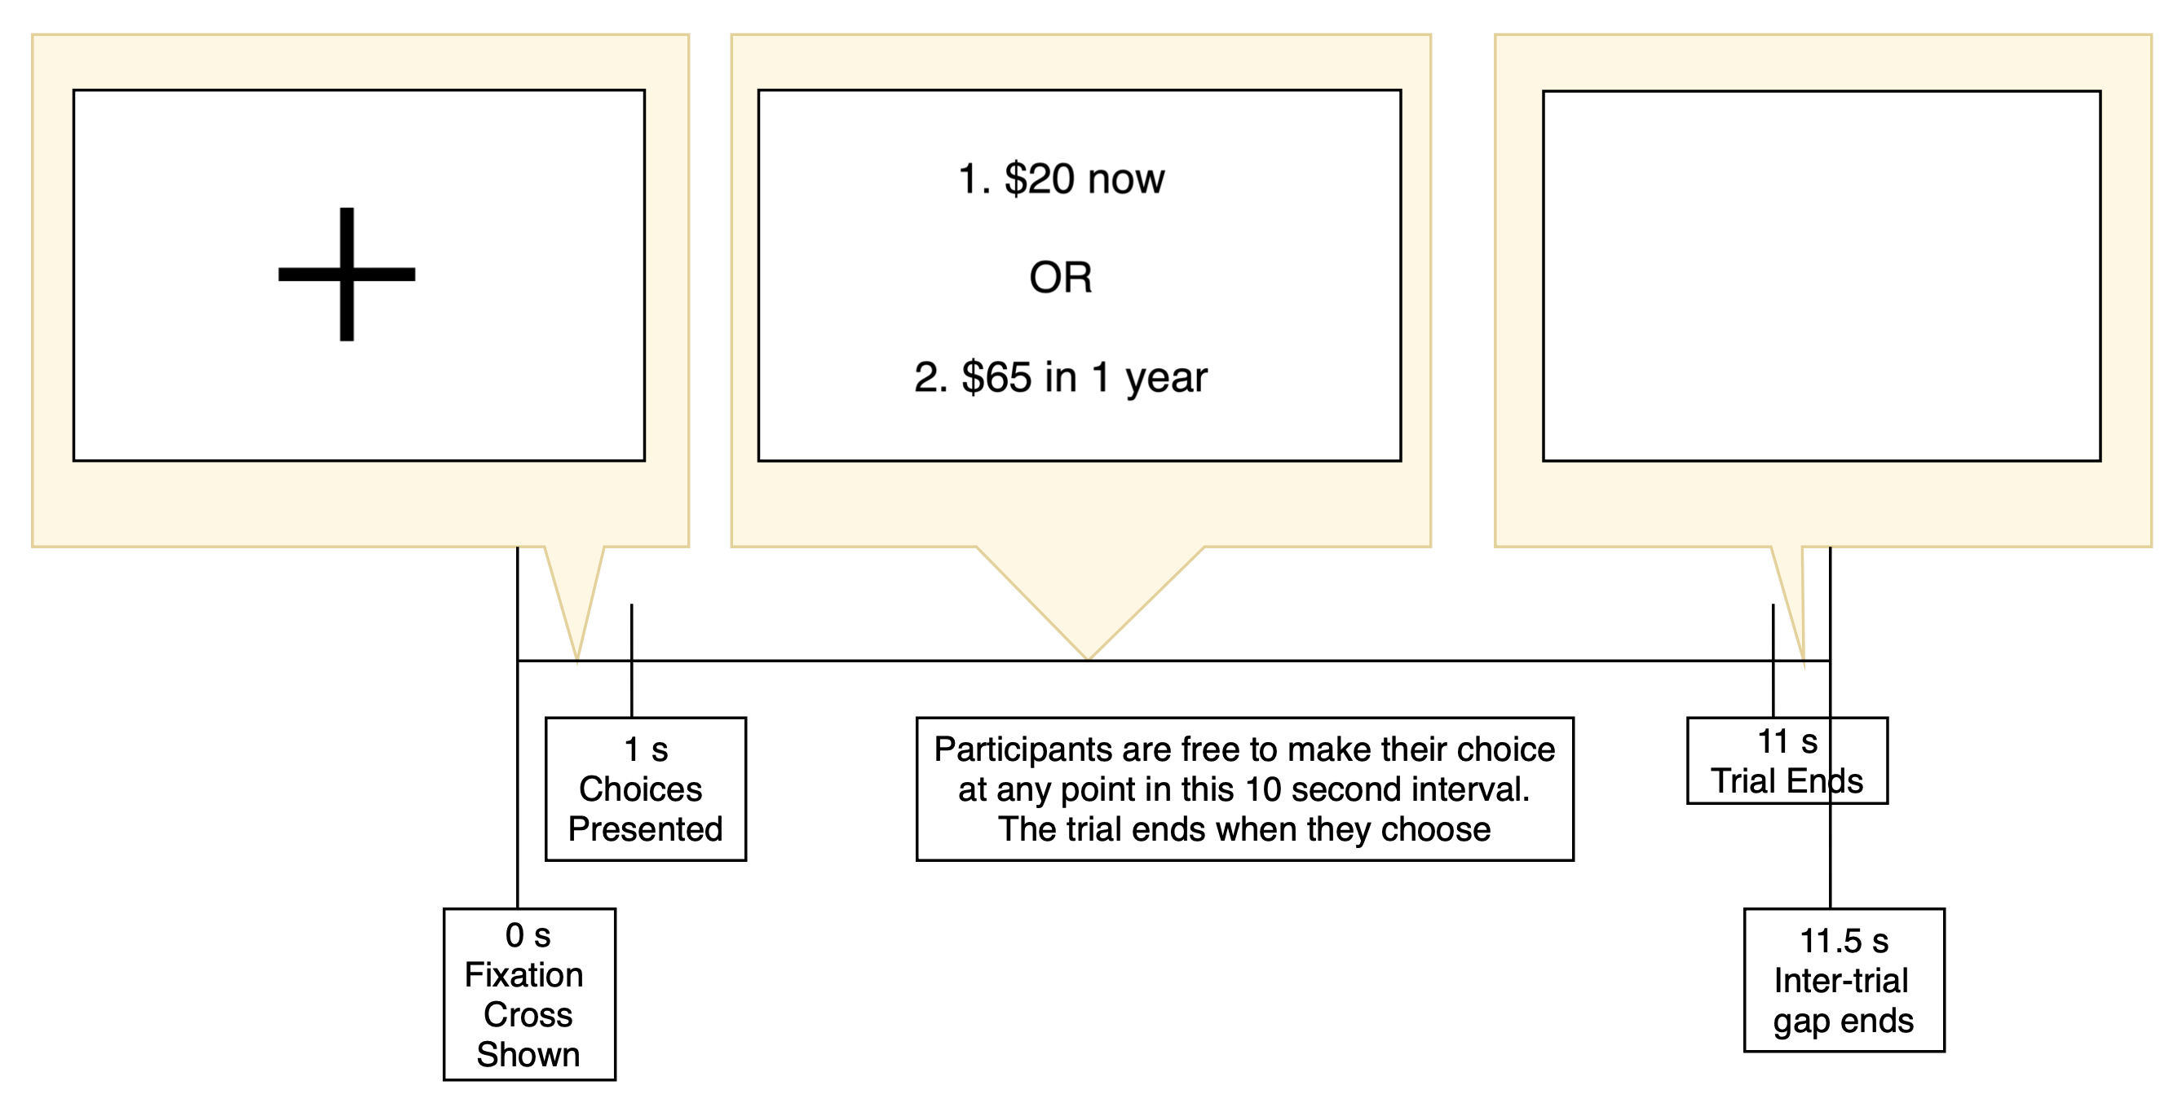

Figure 2: A sample trial, showing all presented screens in succession

We selected unequal measures of value, so that the participants would not be able to quickly calculate equivalent amounts. The lower limit of the choice set was determined by the combination that our temporal discounting group members would always select the immediate option ($20 now vs. $25 at any delay), and the upper limit was a combination in which group members would always select the larger, later amount. ($20 now vs. $130 at any delay). Intermediate values were chosen such that their intervals were unequal. This method of selection was used to try and capture the entire range, as well as the indifference point for most participants. For the delays, we took our inspiration from (Kable & Glimcher, 2007), but removed delays less than 1 week, as these do not seem significant, and added in the duration of 1 year. Also, we presented the time durations with varying scales (i.e. weeks, months, years) instead of a single scale (e.g. weeks) so that the skewed sense of delays associated with semantics are retained. While perceiving delays and amounts, we are usually presented with these semantic associations and odd-values, and we believe that they would always have an impact on the observed discounting behavior.

The trial duration was set to 10 seconds, so that participants have sufficient time to evaluate the delays, and do not provide ‘knee-jerk’ reactions. The survey was designed to collect basic information about the factors impacting their current state of mind and patience, which we believed would include how happy, well-rested or stressed the individual was. Additionally, since their financial conditions could impact their state of mind, we gathered information about their distribution of financial resources. The survey questions were provided with brief descriptions so that the intent and scale of the question was clear to the participants. Happiness and Stress were collected on a scale of 0 to 5, and Sleep was measured in hours. The distribution of economic resources was reported in percentages of monthly expenses across essentials, leisure activities and investments.

# RESULTS

## Psychometric Plots and Parameter Estimation:

The indifference point is the point at which the subjective value of the smaller, immediate reward is perceived to be the same as that of the larger delayed reward. Each delay would be associated with a specific value at which the participant changes the choice they make, i.e. a value that is large enough for the participant to be willing to wait for some period of time. A meaningful example of this is provided in (Basile & Toplak, 2015).

In order to determine the indifference points, binary logistic regression curves were fit to the choices made by the participants. This is equivalent to fitting the equation: $\log\left(\frac{p}{\left(1-p\right)}\right)=a+b*X$, where p is the probability that the selected response is 1, *a* is the intercept, and *b* is the coefficient of the amount *X*. The curve is fit for a specific delay. From the calculated values of *a* and *b*, the point of indifference is found when the probability p = 0.5. Additionally, if the participant selects all 0s, this means that their indifference point is beyond our maximum value of $130. In this case, their indifference point was taken to be an arbitrary larger amount of $300. Following the example of (Kable & Glimcher, 2007), it was assumed that the participant would choose $20 now over $0 now, and the point corresponding to a choice of 0 for an amount of $0 was introduced to the graphs. The curves fit are shown for sample participants in Figure 3a, b and c.

d

e

f

a

b

c

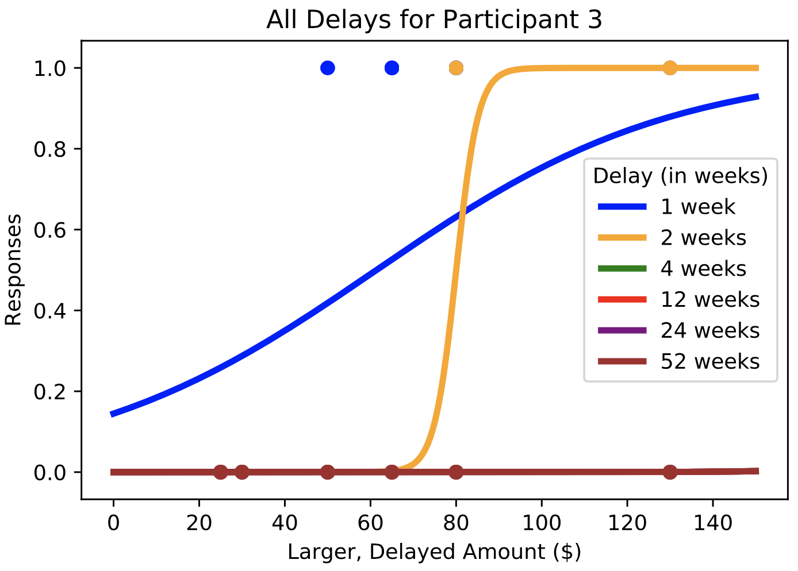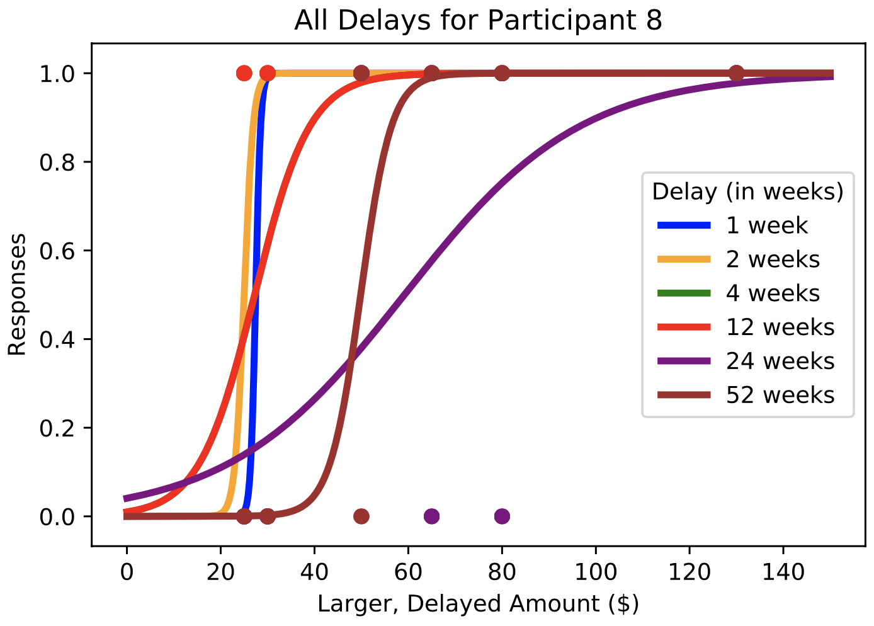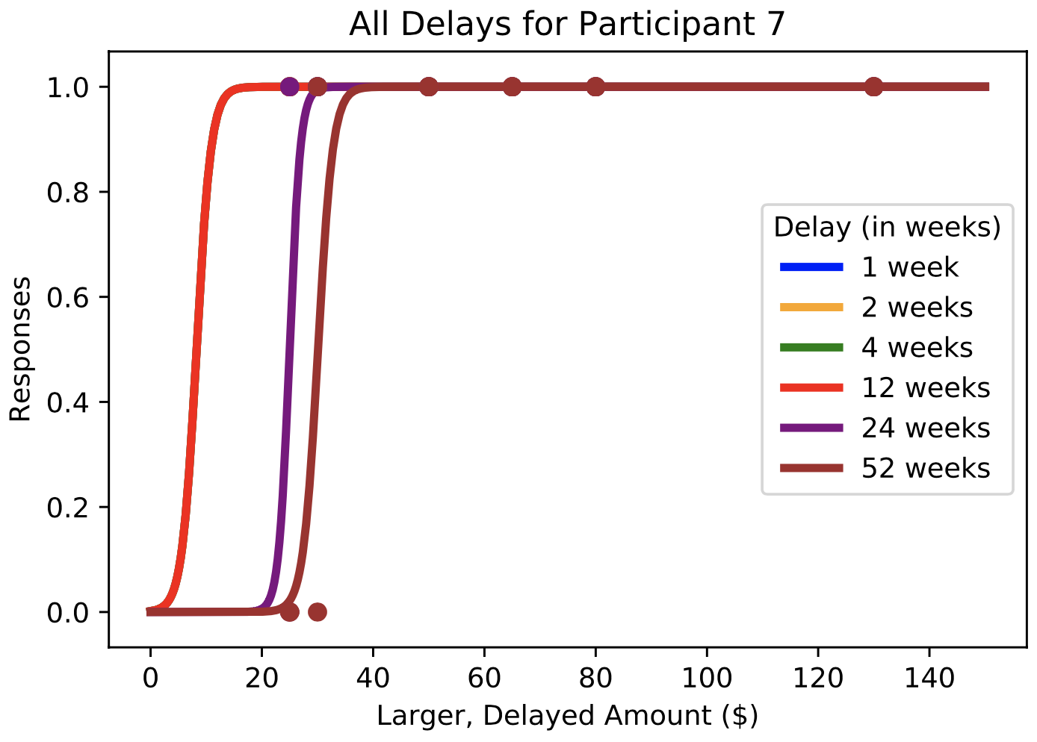

g

h

i

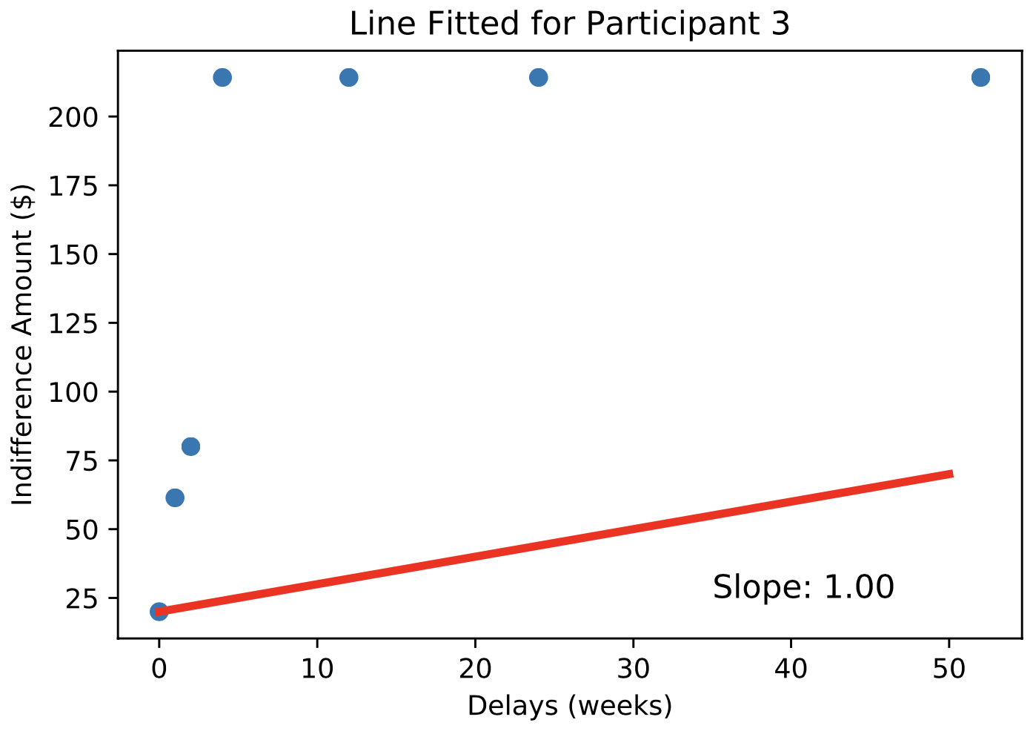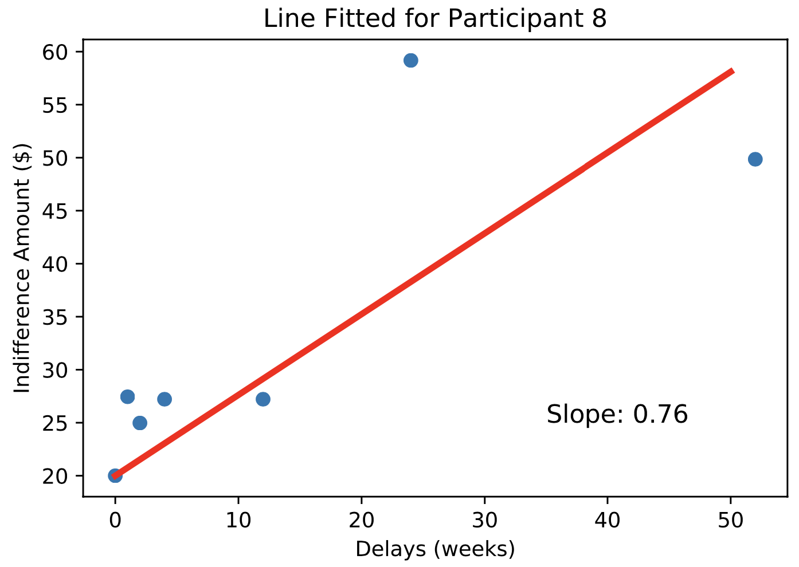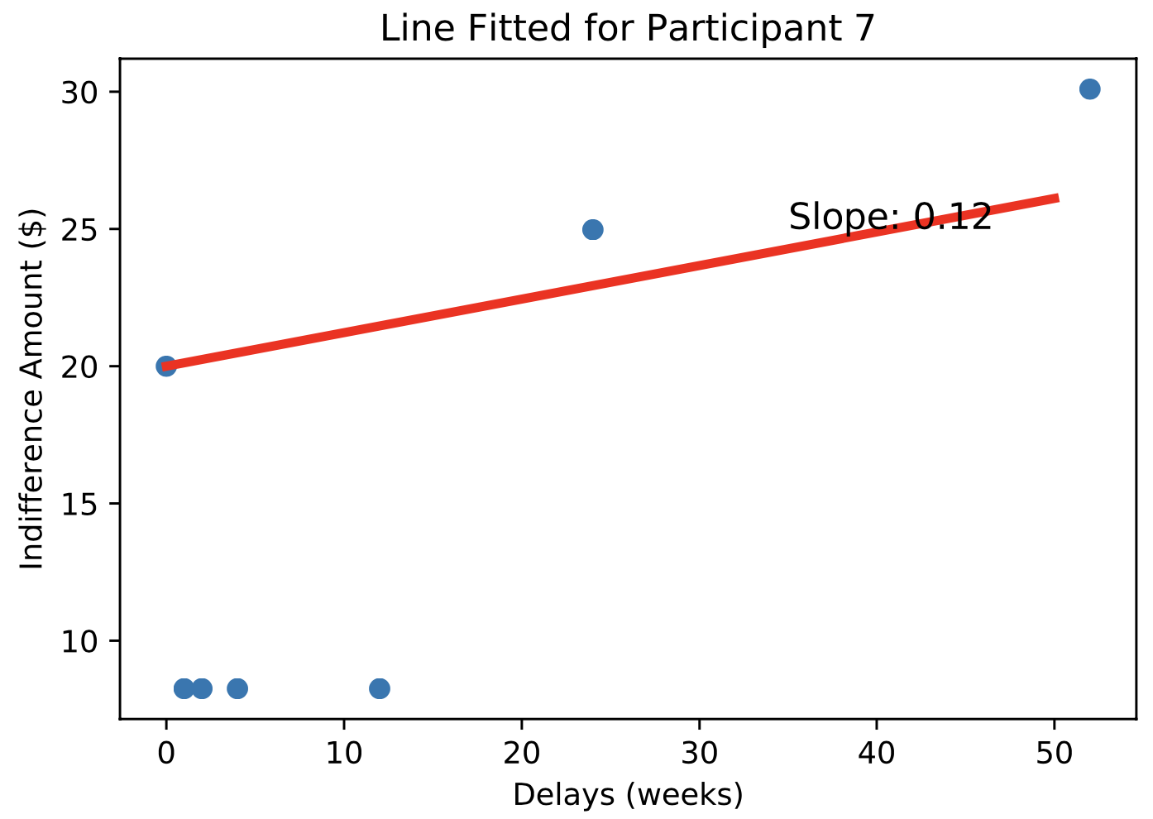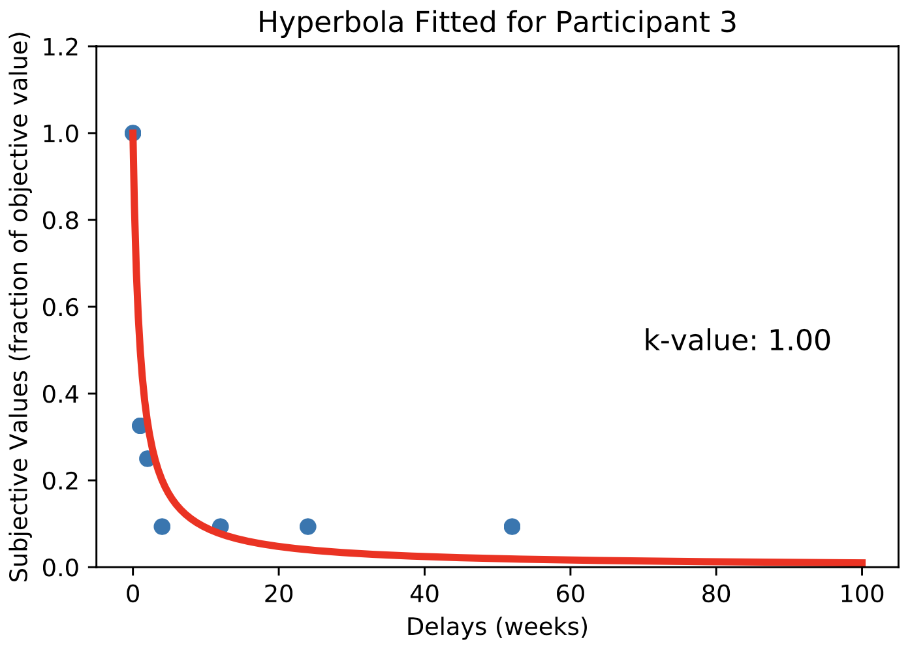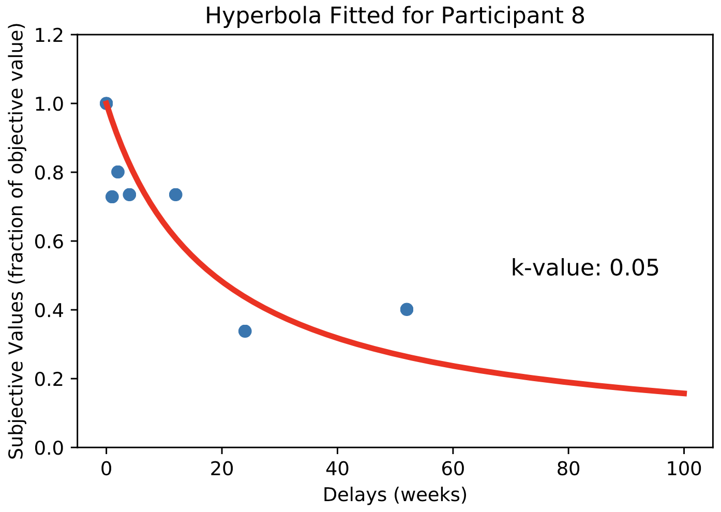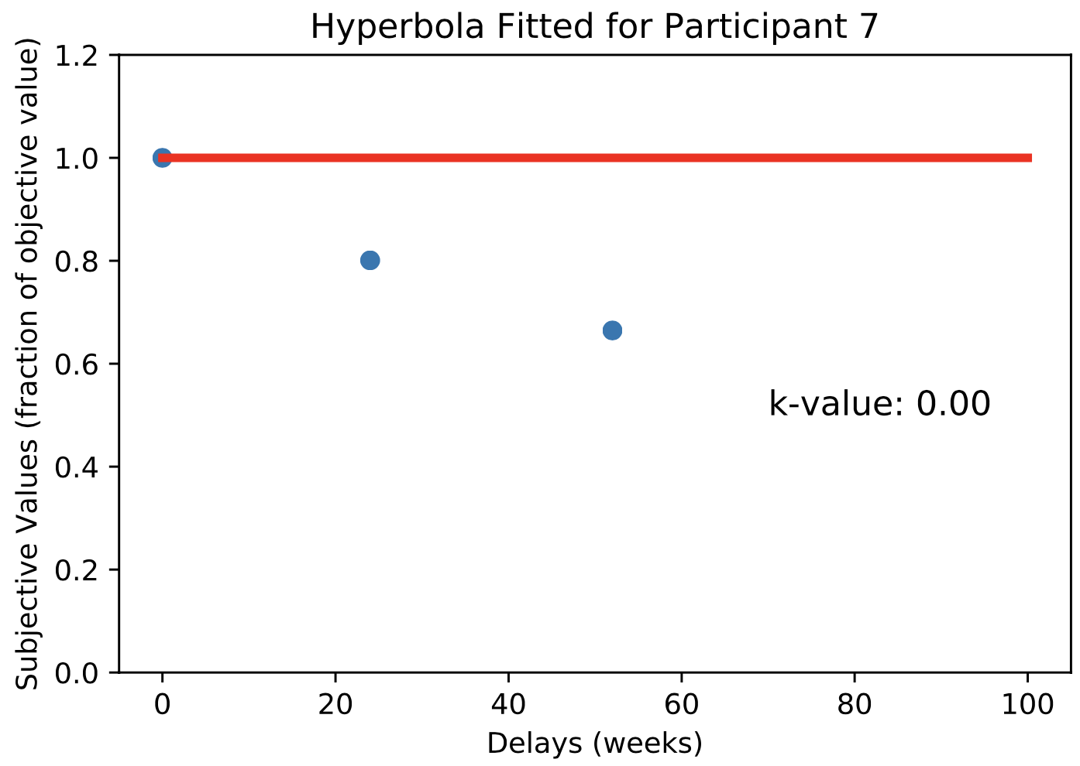

Figure 3: (a-c) Logistic Regression Curves, (d-f) Linear fits for the Indecision Points, (g-i) Hyperbolic fits for the Indecision Points. This figure showcases our most impatient participant (Participant 3), a median participant (Participant 8), and one of the most patient participants. (Participant 7)

Linear fits were then created for all participants, using the least squares optimization method. With an increase in delay, the amount needed to change from an immediate to a later reward increases, which means that the indifference values increase. As visible in Figure 3(d-f), the fit for the most impatient participant had the highest slope of 1, one of the most patient participants was associated with the slope of 0.12, and a median participant had an intermediate slope value of 0.76 – an expected gradient.

Subjective values were calculated as the ratio between the base amount of $20 and the indifference points. (Kable & Glimcher, 2007). The indifference point is where the subjective value is equivalent to the base amount of $20, and this forms the basis for the definition of the ratio as a measure of the current subjective value as perceived by the participant. The decrease of the subjective value with an increase in delay was modelled by a hyperbolic function, as well as the β-δ functions, in accordance with Equations 1 and 2 using the least squares optimization method. The hyperbolic fits for selected patients are shown in Figure 3(g-i). As described in earlier sections, the highest value of k is associated with the participant with the highest discounting, which translates to them being the least patient. An expected gradation between choices and k-values is seen in these hyperbolic fits. Since temporal discounting is better described by a hyperbolic function, further analysis focuses on this fit only. (Green & Myerson, 2004).

a

b

c

d

e

f

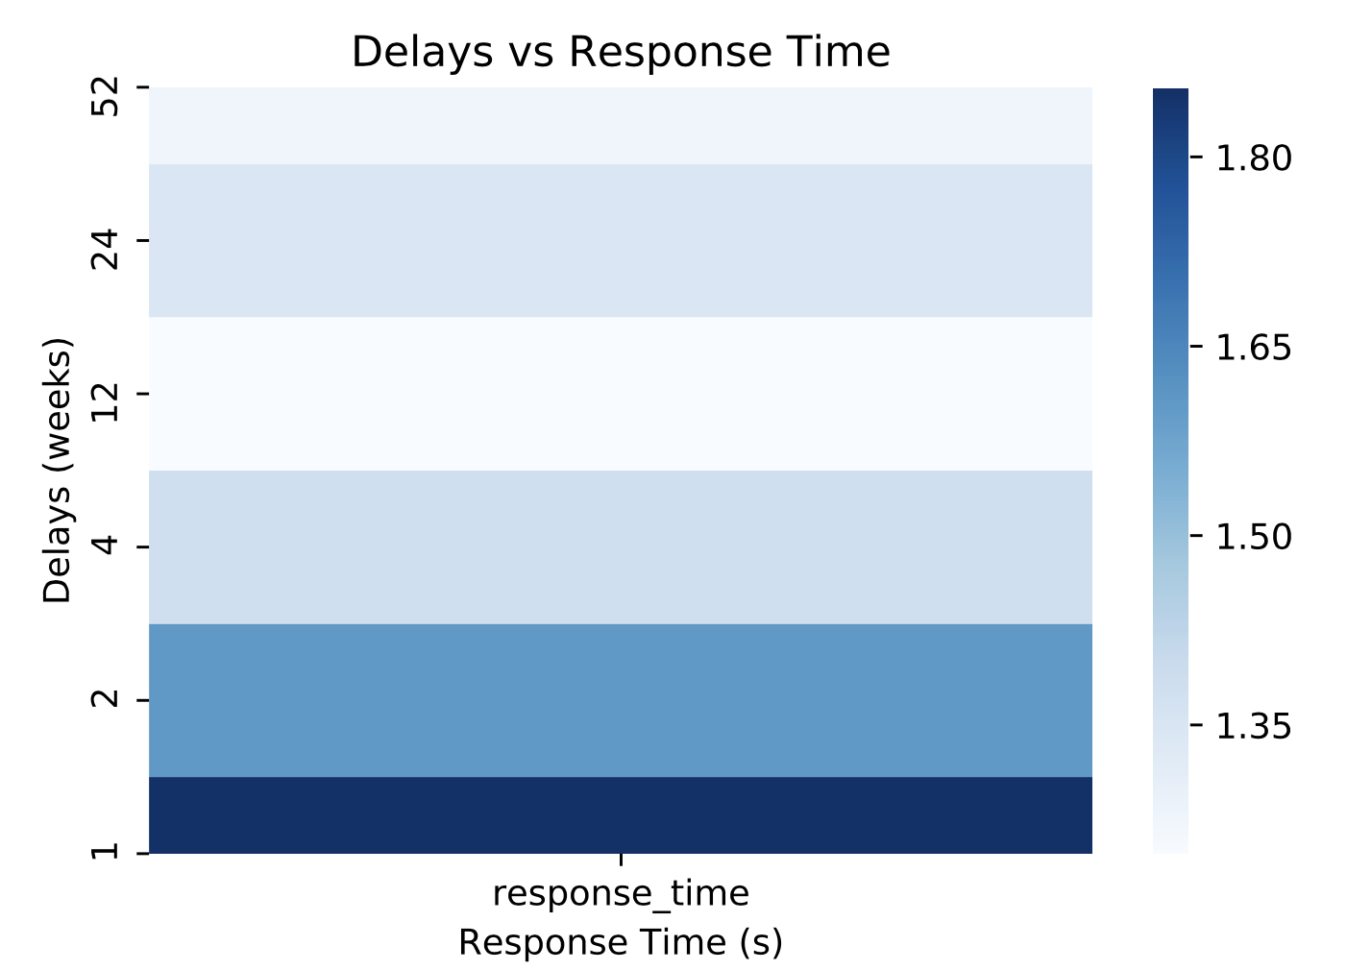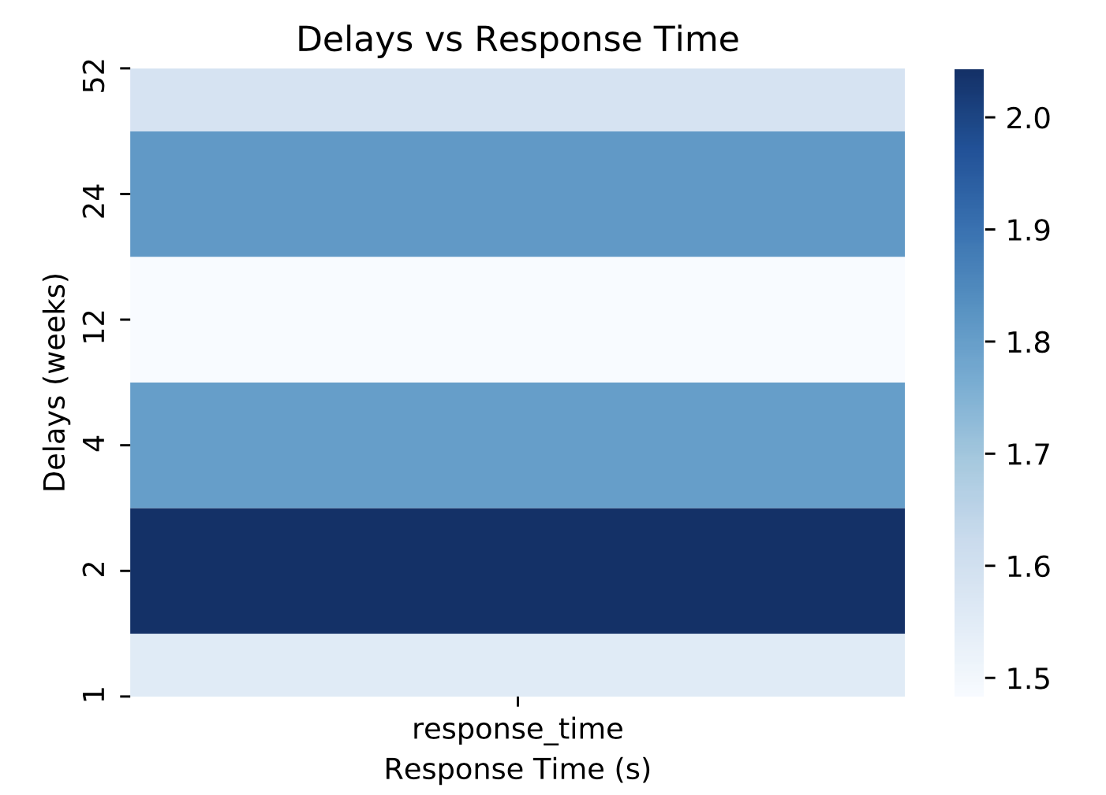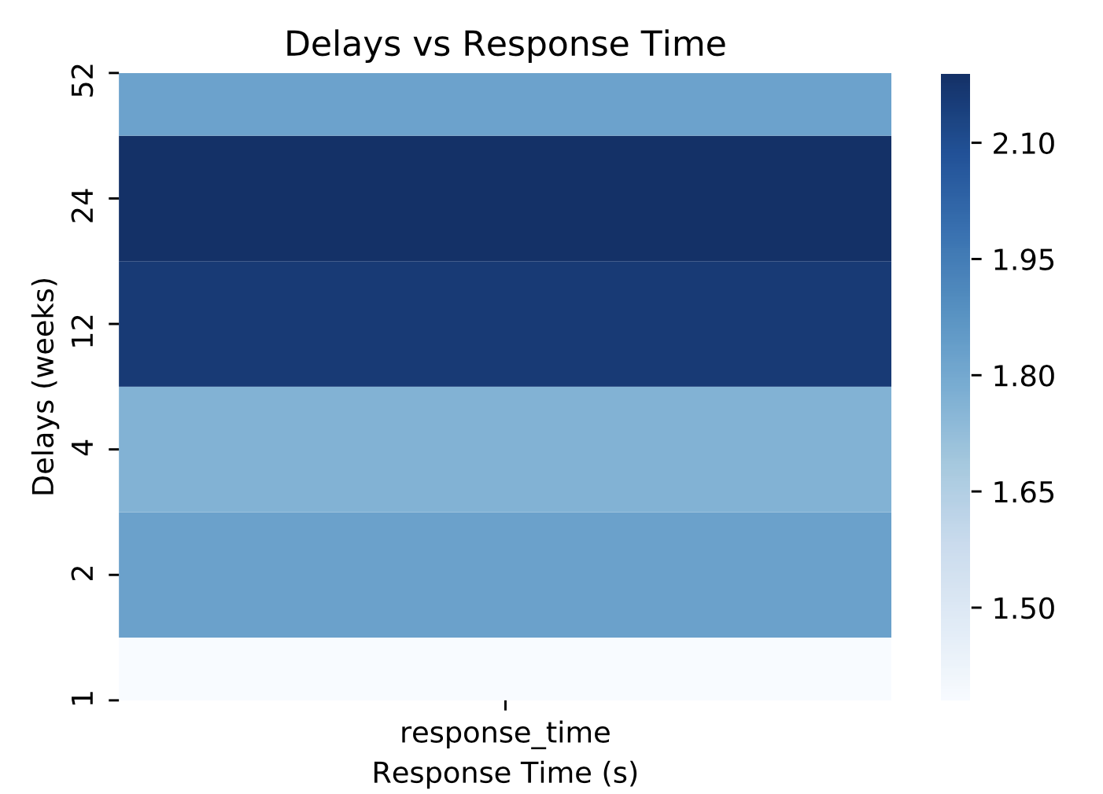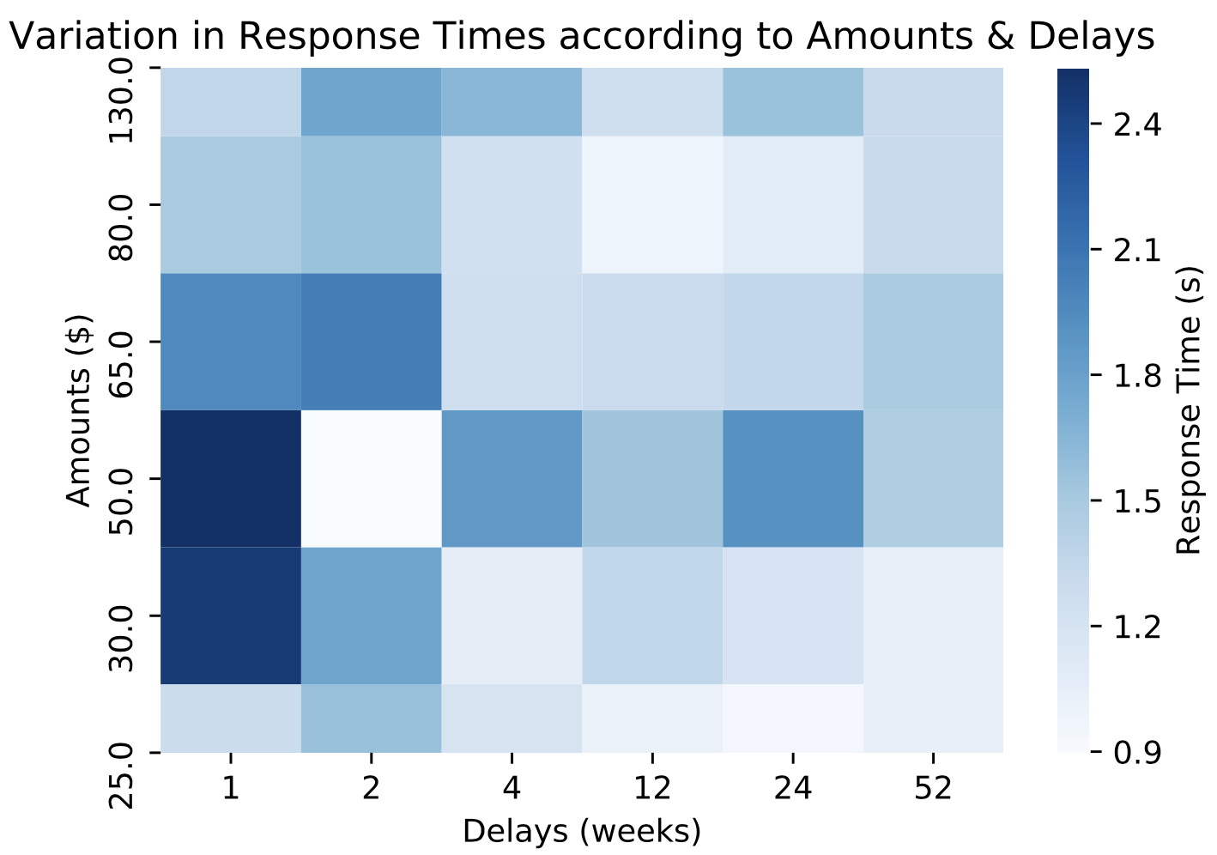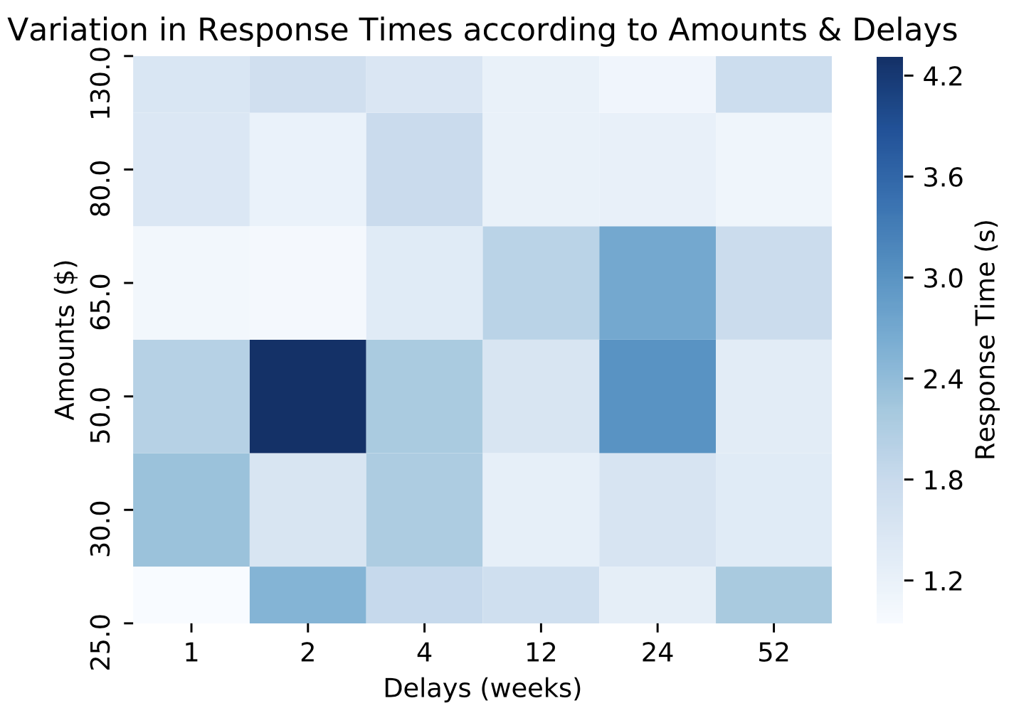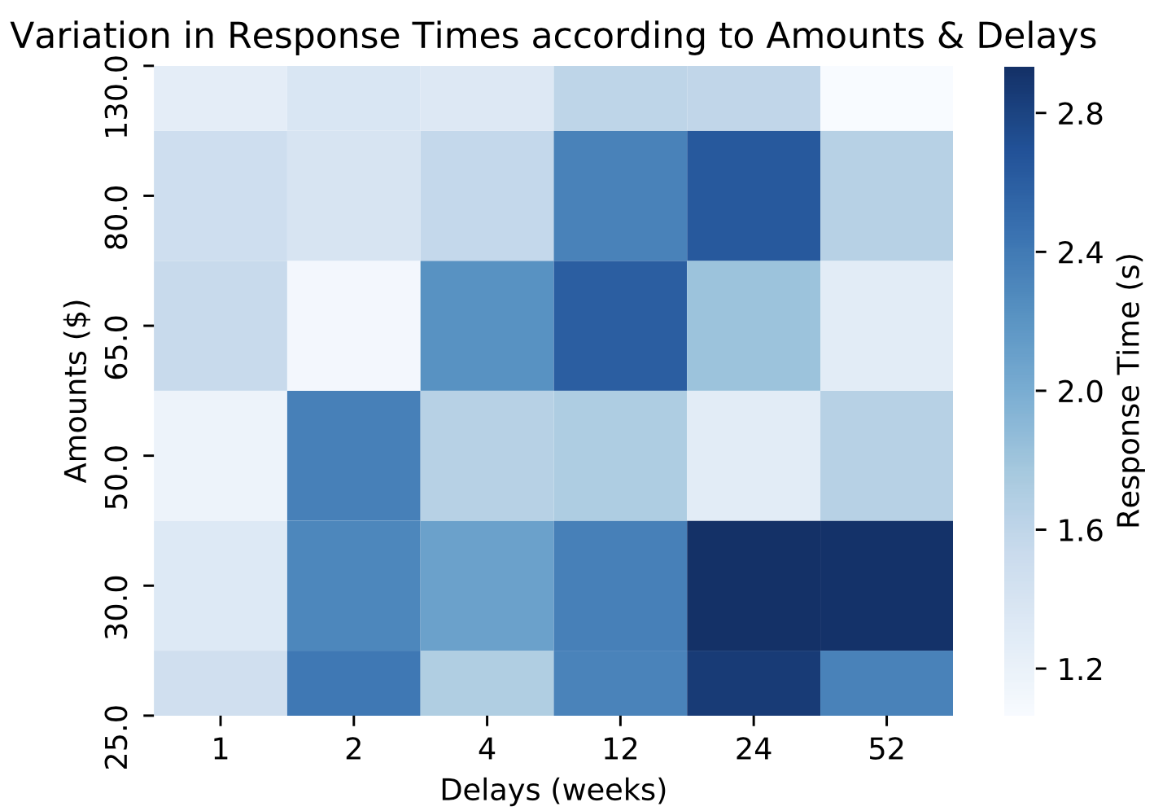

Figure 4: (a-c) show the variation between delays and response times, while (d-f) show the variation in response time with reference to both the amounts and delays. Figures a. and d. correspond to participant 3, b. and e. correspond to participant 8, and c. and f. correspond to participant 7.

## Heatmaps of Response Times:

Delays are a critical variable in temporal discounting (Green & Myerson, 1997). The response time for participants is expected to vary with delays, as well as their subject-specific discounting parameter. As seen in Figure 4a, participant 3 responds very quickly, and in fact seems to reach a conclusion faster for later delays. This is moderated in participant 8, seen in Figure 4b, and even further in participant 7 (Figure 4c), whose response times seem to be in the higher ends of the visible [1.5 – 2.1] response time range. In the case of our temporal discounting setup, there is also a variation in the amount being offered immediately and after a delay. The amount would also have an impact on the decision-making process of the participant. This decision-making time variation with amount and delay is represented in heatmaps for participant 3 (Figure 4d), 8 (Figure 4e) and 7 (Figure 4f). The figures align with our expectation, as 3 is again quick at reaching decisions, while 7 deliberates for an extended time, and 8 is intermediate. (The scale of response times changes for 8).

## Reliability of Estimated Parameters:

The reliability of estimated parameters is checked by using bootstrapping techniques. For 500 iterations, a set of subjective values and delays were sampled with replacement, and the hyperbolic discounting function was fit for the same. Shown in Figure 5, the

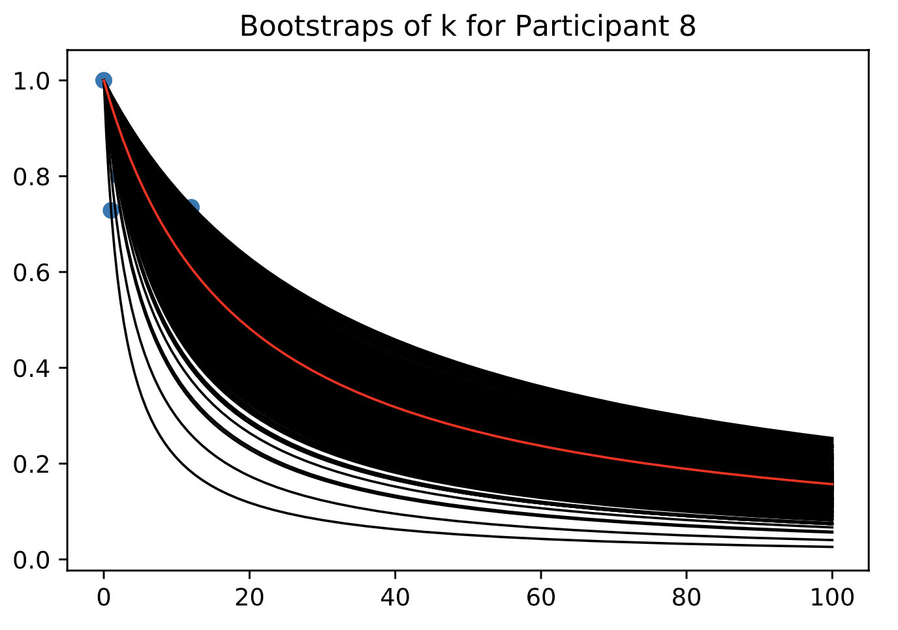

Figure 5: Bootstraps were performed to check the goodness-of-fit for parameter k. For all participants, the k-value lay within the bounds of the bootstrapped values. Bootstraps created for participant 8 are shown as a representation.

value of ‘k’ was within the range of all bootstraps extracted. This held true for all participants. The 95% confidence interval bounds were also calculated for all participants. As an example, for participant 8, the confidence interval was 0.03-0.12, and the k-value estimation was associated with an error of 0.027. By calculation of associated error values, confidence intervals, and ensuring that the estimated k-value from a single hyperbolic fit of the original data lies within the bootstrapped values, the validity of these models is established.

## Trend Analysis with Survey Responses:

After building the hyperbolic discounting functions, and estimating as well as validating the subject specific parameter ‘k’, trend and correlation analysis could be done with the demographic and state of mind survey responses. Before performing the trend fitting, subjects 5 and 7 were excluded because most of their responses were 1s, and hence the estimated k was around 0. Subject 3 had selected 0 as their response in majority of cases, and the estimated k was around 1. These subjects were included during the calculation of k as well as the basic analysis, since although it is unexpected to us, it is a form of behavior, which may have simply been a function of the choices presented. However, to mitigate the effect of outliers on the trend estimation, these outlier values of k were excluded from further analysis.

As an initial step, the Pearson Correlation Coefficients were calculated for the collected factors from the survey responses. The Pearson Coefficient is a measure of linear correlation between two sets of data. It depends on the assumption that the data is continuous, and hence the categorical variable of Degree was not evaluated. The Pearson coefficient is essentially a normalized measure of the covariance, and the value always lies between -1 and 1. By removing outliers, ensuring that there are related pairs, and looking for linear matches only, the other constraints of this correlation calculation are met. The coefficients and their associated p-values are shown in Table 1. For this analysis, we only have 10 participants, and hence the absence of a significant p-value or obvious trend is to be expected.

Table 1: Pearson Correlation Coefficients

|  |  |  |
| --- | --- | --- |
| **Factor** | **Correlation Coefficient** | **P-value** |
| Age | 0.19 | 0.67 |
| Essentials | 0.28 | 0.54 |
| Happiness | -0.43 | 0.34 |
| Investments | 0.23 | 0.62 |
| Leisure | -0.23 | 0.62 |
| Sleep | 0.33 | 0.47 |
| Stress | 0.17 | 0.72 |

The most significant relation, in terms of magnitude of correlation and the associated p-value, is that of happiness. Intuitively, this makes sense, as when a person is happier, they tend to be more patient and tolerant of situations and delays, leading to less discounting, and ultimately a lower k-value. The positive linear relation between sleep could plausibly be explained by the fact that low sleep leads to some cognitive disorientation, as a result, they are willing to wait for longer delays and have smaller k-values. Or maybe they just want to go to sleep. The positive linear relation with stress can be explained by the fact that it is easier to wait for longer delays and be more patient when a person is less stressed. These relations of the k-parameter and the factors of Happiness, Sleep and Stress are shown by means of a linear fit in Figure 6 a, b and c respectively.

a

b

c

d

e

f

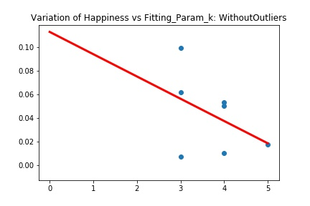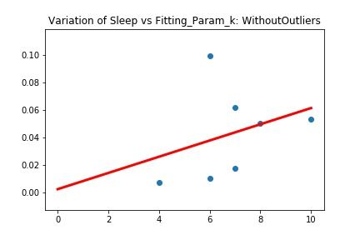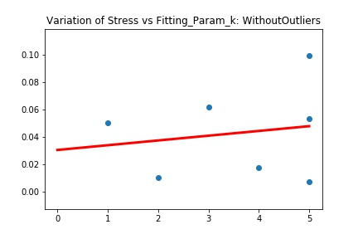

g

h

i

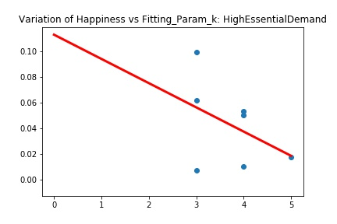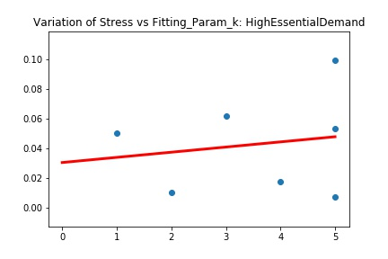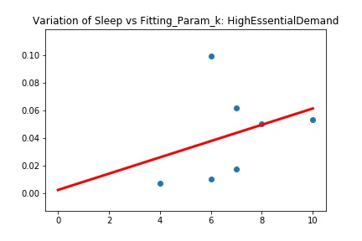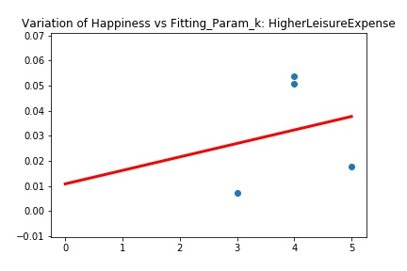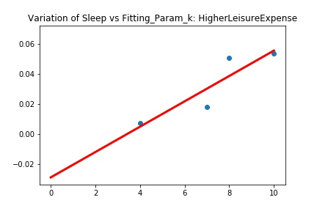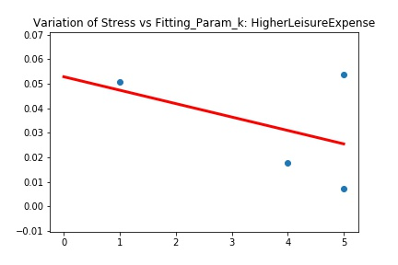

Figure 6: This shows the variation of the calculated hyperbolic fit parameter ‘k’ with factors that impact the state of mind, namely Happiness, Stress and Sleep, calculated by self-reported measures (a-c). There is also a possibility that having some form of economic stress or ease could impact these factors, which is explored by studying the trends in the cases of High Essential Demand and Higher Leisure Expenses.

Different socioeconomic conditions could also have an established impact on state of mind, which is always present, unlike the ephemeral states achieved by Happiness, Stress or Sleep duration impacts. Having a high expense load for essentials may lead to a focus on ensuring that there are sufficient funds to get through the month. A high expense load was taken as a value higher than 50%. The trends observed earlier held, which could be because the threshold was too low to determine the impact of this factor, or just a lack of variation in the population. Having a high expense on leisure activities, here defined by a threshold of higher than 10% based on the values reported in the survey, may indicate a ‘live in the moment’ mentality. However, this did not lead to any meaningful trend either, but a reversal in the happiness trend was noted, which may simply be because of limited data.

Validity of Results and Statistical Assumptions:

The validity of the hyperbolic fit has been well-established by existing studies (Kable & Glimcher, 2007; Basile & Toplak, 2015). Estimates of k were bounded within the bootstrap estimates, with confidence intervals and errors calculated. The observed subjective value parameters and hyperbolic curves follow known characteristics of temporal discounting, leading to an empirical evaluation of the presented results. The least squares and binomial logistic regression fits are data driven, and hence are appropriate for the curve fitting process followed. By fitting trends, the results of the Pearson coefficient can be partially validated, although as described by the p-values, the Pearson coefficients are not significant. The data generally appears to follow the required assumptions for this statistical model. The other analyses and results report from the trends are based on the visual information presented and intuition.

# DISCUSSION

## Implications of Results for Decision-Making:

Our results reinforce the strong basic hypothesis of temporal discounting, which is that subjective value of an amount diminishes with delay. In general, temporal discounting depends on delays and amounts, which is supported by our findings. We are able to validate the hyperbolic fit for the discounting function and show expected relations between the hyperbolic fitting parameters and subject tendencies. The hyperbolic fitting parameter ‘k’ is representative of some measure of patience, as reflected in the response times as well. Also, although we used unusual amounts in our setup, this does not seem to have had an impact on the results. This implies that subjects may be working with estimates or ranges or even fixed rules instead of exact probability or expected value estimates.

An important finding of our work is that state of mind parameters will have an impact on patience measures (the hyperbolic fitting parameter k), as well as the observed discounting curve, and as a result, on the observed temporal discounting tendencies in subject. While we have explored only a few parameters with very few subjects, and the results are hence not significant, there appears to be an inverse relationship between happiness and discounting tendencies. Stress and sleep seem to be related to the discounting tendency directly. These relations should be studied in thorough detail, to determine to what degree these factors impact discounting tendencies. This will have a direct influence on the decisions made by people, because the ability to adjust the value of a reward in the future appears to be dependent on the present state of mind, and current emotional as well as physical state. A number of other physiological and psychological measures could be evaluated in a larger, more detailed study to confirm the existence and pattern of these relations.

The model parameters and hyperbolic fits found by our experiments align well with the results found by existing work. (Particularly Kable & Glimcher, 2007). Although the parameter values are out of bounds for some participants, this can be attributed to a limited set of amount and delay combinations used. The estimated k-values in the case of non-outlier participants seem to be in similar ranges as those found by earlier articles. Our temporal discounting data was from students (who are relatively more patient and willing to undertake long-term waits – as showcased by their enrolment in long-term degree programs), while the Kable & Glimcher (2007) results were from paid participants. With this in mind, we expected that our cohort would tend to be more patient, and this was what we found via our experiments as well. (Median participant in Kable & Glimcher (2007) had a fitting k-value of 0.0097, while our median participant had a fitting k-value of 0.05).

## Limitations & Future Work

A major drawback of our experiment was that we were not able to offer any realistic incentive or time-delayed reward, and hence participants were working in a purely hypothetical setting. In the absence of a reward, it is likely that they may not have generated the neural response associated with reward evaluation. It may be imperative to include actual rewards to get reliable estimates for behavioral analysis.

Although we did get generally good fits for the data, some of our participants showed unexpected behavior, which may be attributed to the amount and delay combination presented. Our observations explained to us why having different, shorter delays, with higher amounts at stake is a part of the common practice. Having more repetitions of the trial sets may lead to more stable estimates.

Our results dealt with only a few participants, as a result of which, most of our trends were not significant. The survey presented dealt with only basic state of mind parameters like happiness and stress. However, the correlations that we found even with this limited data seem to suggest that these are important factors that could modify a person’s discounting abilities. Since this has a direct impact on how evaluations of situations are done, or how decisions are made from that point onwards, exploring the relation between physiological and psychological variables and temporal discounting may be an exciting avenue.

A higher value of ‘k’ implies a higher tolerance for discounting, and may be associated with a willingness to add in more effort for long term goals. This is a subject specific parameter, but its variation across situations and times of day would provide more information on what other factors could impact it. If it is a developed personality trait, independent of the current situation or state of mind, the k value could be indicative of a willingness to accept long-term goals.

The relation between socio-economic status and temporal discounting could not be explored in more detail. This question, as well as the impact of cognitive disabilities, could help establish the neural basis of temporal discounting, as well as a thorough map of how it evolves circumstantially.

# CONCLUSIONS

We were able to build a behavioral temporal discounting experiment, in which the participants chose between a fixed immediate amount of $20, and a randomly selected amount ranging from $25 to $130, after a randomly selected delay ranging from 1 week to 1 year. Using this data, we found the indifference points for the different delay values by fitting binomial logistic regression curves. From these indifference values, subjective values were estimated, and a hyperbolic discounting curve was fit for the variation of subjective value with delay. These results aligned with that of existing research work. The validity and goodness of fit of the parameters was established by bootstrapping. Heatmaps were generated to understand how reaction times varied with delays and amounts. Finally, trend and correlation analyses were done between the discounting parameters and the survey questions related to participant’s state of mind. These trends were limited by the number of participants and were not statistically significant, but independent linear relations between happiness, stress, sleep and the temporal discounting factor were found, which should be explored in more detail. The behavioral results aligned well with our expectations, including the higher levels of patience that we expected to see in our population.

Thus, overall, we were able to execute a successful temporal discounting experiment, which deepened our understanding of the processes involved in the analysis and the observed behavior patterns, provided important insights, and laid a basic framework for possible future experiments.

# References

1. Kable, J. W., & Glimcher, P. W. (2007). The neural correlates of subjective value during intertemporal choice. *Nature neuroscience*, 10(12), 1625–1633. <https://doi.org/10.1038/nn2007>
2. Peters, J., & Büchel, C. (2010). Episodic future thinking reduces reward delay discounting through an enhancement of prefrontal-mediotemporal interactions. *Neuron*, *66*(1), 138–148. <https://doi.org/10.1016/j.neuron.2010.03.026>
3. Kable, J.W., and Glimcher, P.W. (2010). An ‘‘As Soon As Possible’’ Effect in Human Inter-Temporal Decision Making: Behavioral Evidence and Neural Mechanisms. *J. Neurophysiol*., in press. Published online February 24, 2010. 10.1152/jn.00177.2009.
4. Critchfield, T. S., and Kollins, S. H. (2001). Temporal discounting: basic research and the analysis of socially important behavior. *J. Appl. Behav. Anal.* 34, 101–122. doi: 10.1901/jaba.2001.34-101
5. Basile, A. G., & Toplak, M. E. (2015). Four converging measures of temporal discounting and their relationships with intelligence, executive functions, thinking dispositions, and behavioral outcomes. *Frontiers in psychology*, *6*, 728. <https://doi.org/10.3389/fpsyg.2015.00728>
6. Green, L., & Myerson, J. (2004). A discounting framework for choice with delayed and probabilistic rewards. *Psychological bulletin*, *130*(5), 769–792. <https://doi.org/10.1037/0033-2909.130.5.769>
7. Green, L., Myerson, J., and McFadden, E. (1997). Rate of temporal decreases with amount of reward. *Mem. Cogn.* 25, 715–723. doi: 10.3758/BF03211314